**Architectuur Schema - Groep 7**

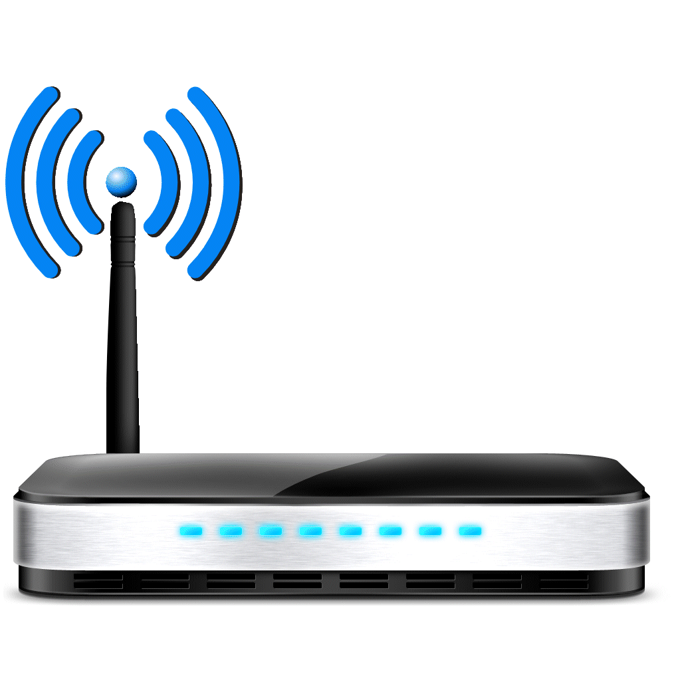

Router

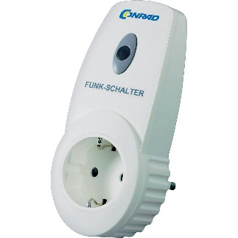

LED

RF-Schakelaar

Wi-Fi

Ethernet Kabel



~3

7

8

………. ……..

LDR

Temp Sensor

Weerstand

Buzzer

Breadboard

+

-

Arduino Uno + ethernet Shield

A3

A4

GND

5V

GND

433 MHz

|||

**VCC**

**DATA** ∙∙∙ **GND**

RF-Zender

….…. …...